**MAINT Data Validation**

The maintenance system for MTU products is based on a preventive maintenance concept. Preventive maintenance facilitates advance operational planning and ensures a high level of equipment availability. The maintenance intervals as well as the required scopes of maintenance tasks are based on operational experience and therefore to be considered as recommendations. Additional maintenance work and/or changes to the maintenance intervals may be required in the case of difficult operational and ambient conditions.

Adherence to the specified maintenance intervals is essential to maintain product safety.

The intervals according to which the maintenance tasks have to be carried out are specified as operating

hours and time limits. Whichever value is reached first shall apply.

The maintenance intervals are determined and verified by the load profile. Load profiles can be evaluated by the Service Partner of MTU. Reading out load profile data is recommended for the first time after between 500 and 1000 operating hours depending on the application concerned, or after changing the duty profile or operating area.

The individual maintenance intervals are assigned to the qualification levels QL1 to QL4.

QL1: Operational monitoring and maintenance work which does not require disassembly of the product.

QL2: Exchange of components and parts in case of repair (corrective only, not part of the maintenance

schedule).

QL3: Maintenance work which requires partial disassembly of the product.

QL4: Maintenance work which requires complete disassembly of the product.

Additional notes on maintenance and preservation:

The relevant component manufacturer's instructions apply with respect to the maintenance of any components which do not appear in this maintenance schedule.

For the change intervals of fluids and lubricants, refer to the corresponding Fluids and Lubricants Specifications.

If the engine is to remain out of service for a longer time period, MTU recommends to carry out a monthly test run until engine operating temperature is reached. If the engine is scheduled to remain out of service for

> 1 month, carry out engine preservation procedures in accordance with the Preservation and Re preservation

**1.Maintenance task tolerances**

Maintenance tasks shall be completed within certain tolerances. Taking full advantage of such tolerances does not influence the scheduled timing of the ensuing maintenance task.

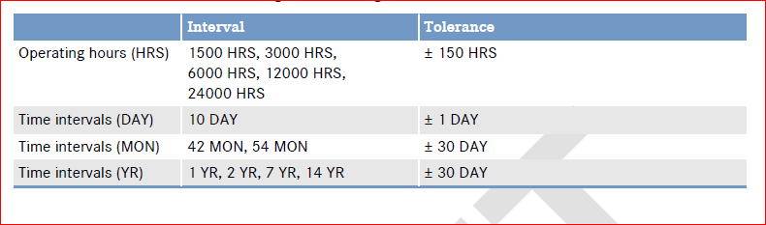

Example:

Asset A maintenance interval hours is 3000

Then

Asset A Tolerance limit is 2850 to 3150

Columns that can be verified

* Tolerance Operating Hours Minus
* Tolerance Operating Hours Plus
* Tolerance Operating Hours
* Tolerance Days Plus
* Tolerance Days Minus
* Tolerance Days

2. Interval Operating Hours

Example:

1. Look for maintenance plan name from the PDF / EXCEL ## **MA50186_10E**
2. Choose one task name **(WM00106)** from the PDF and look for interval opt hours against to it
3. Its 12000 as in below example



1. Load Maintenance tile for the Fleet / PP/Trains
2. Filter with the Maintenance plan name 🡪 then filter with task name 🡪 Check for Interval Operating Hours

**ER: Value has to match between PDF and UI**

**3.** **Latest Completion Hours**

* Latest Completion Hours = Interval Operating Hours + Tolerance Operating Hours

4. Latest Completion Days:

* Latest completion Days = Commission date + Limit

EX:

Commission date : 01-01-2020 (Need to check in DB)

Limit : 7 years

Latest completion Days = 01-01-2027

**5.Interval Days**

**Interval Days = Limit * 365**

EX: 7 years is the limit, the 7*365 = 2555

6.Earliest Begin Hours

Earliest Begin Hours = Interval Operating Hours - Tolerance Operating Hours

7.Due at Operating Hours by Interval Operating Hours Compliance/ Due at Operating Hours by Interval Operating Hours:

Derived from the Database.

8.Due in Operating Hours by Interval Operating Hours Compliance/ Due in Operating Hours by Interval Operating Hours:

**Due in Operating Hours by Interval Operating Hours Compliance = (Due at Operating hours by interval operating hours Compliance - Current operating hours)**

**9.** **Due at Days by Interval Days Compliance / Due at Days by Interval Days:**

**Derived from the database.**

**10.** **Due in Days by Interval Days Compliance/** **Due in Days by Interval Days**

= (Due at days by interval days – Current date)

11. Description**:**

Can be verified against maintenance plan description in the document

**12) Next Maintenance Due:**

Test case: [[GOS-5206] To Verify 'Next Maintenance Due' UI Calculation when 'Maintenance Level Unit' is 'H' (hours based) and 'Y' (year based) - Jira (atlassian.net)](https://rrps-go.atlassian.net/browse/GOS-5206)

Fleets : GWML / WOE (Maintenance level unit is hourly based for only these fleets as of now)

**Formula 1 : NextMaintenanceDue (In hours for GWML /WOE) = NextMaintenanceLevel – CurrentOphrs**

##Next maintenance due value will be available for only category number 710

1. When 'Maintenance Level Unit' is 'H' (Hourly based)

Then use <Formula1> for the UI calculation

Then verify the 'NextMaintenanceDue in hours' cell value should match with the <formula1> output

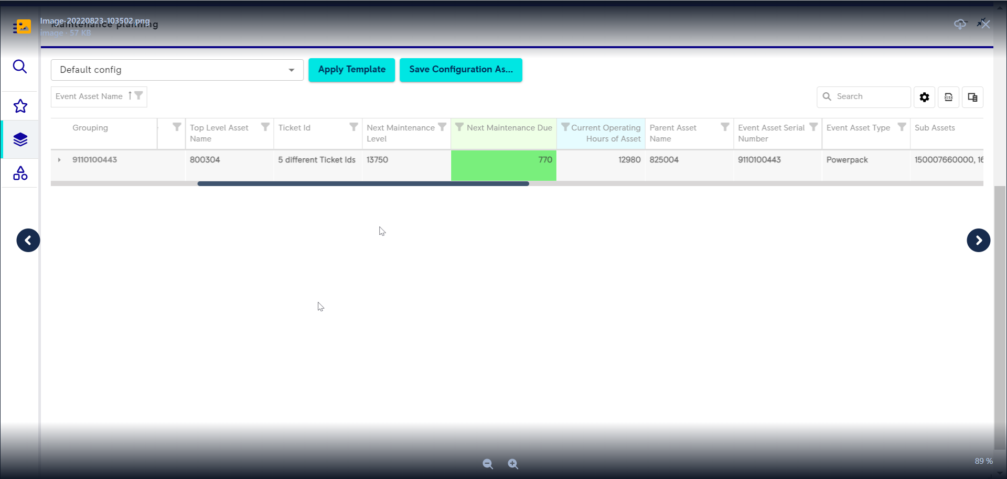

1. When user selects <asset> from <fleet>

And 'Next maintenance level' value is available

And 'operating hours' are available

When the <formula1> output is '0' Then the '0' should be shown in the cell

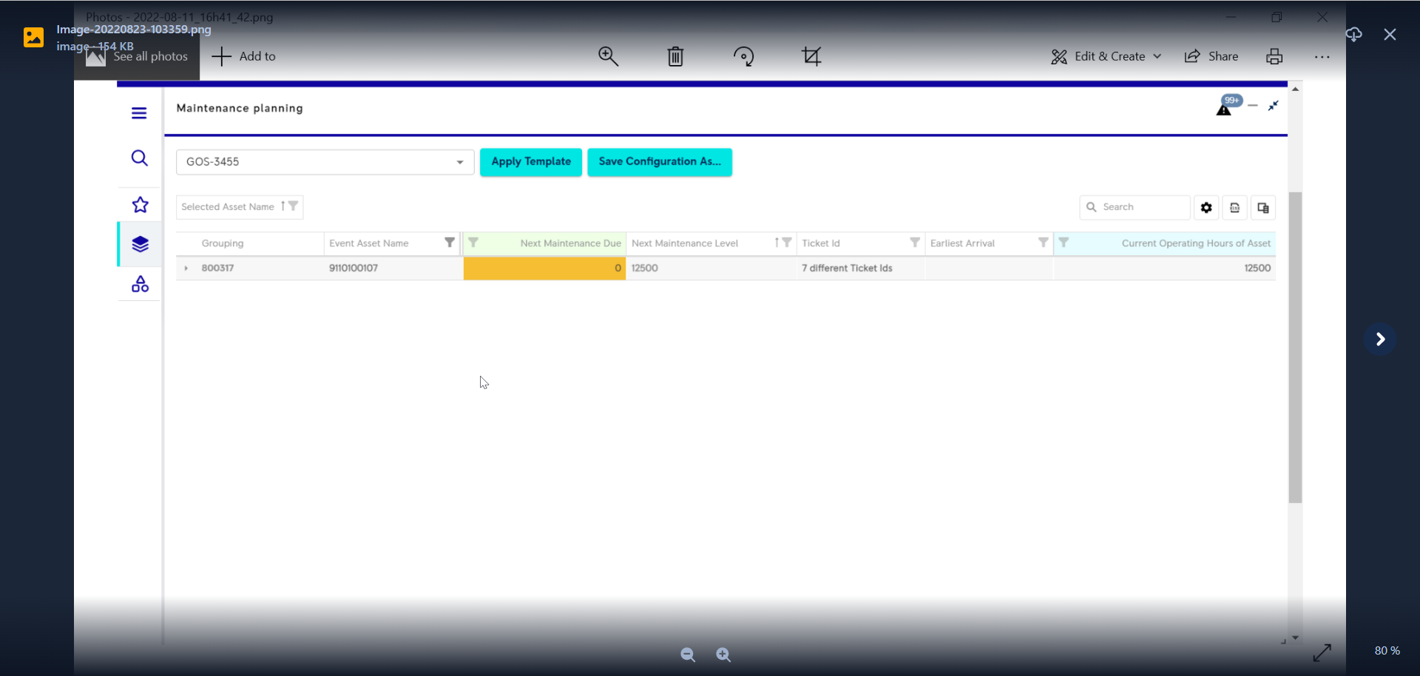

1. When user selects <asset> from <fleet>

And 'Next maintenance level' value is Not available

And 'operating hours' are available

Then Due value should be null

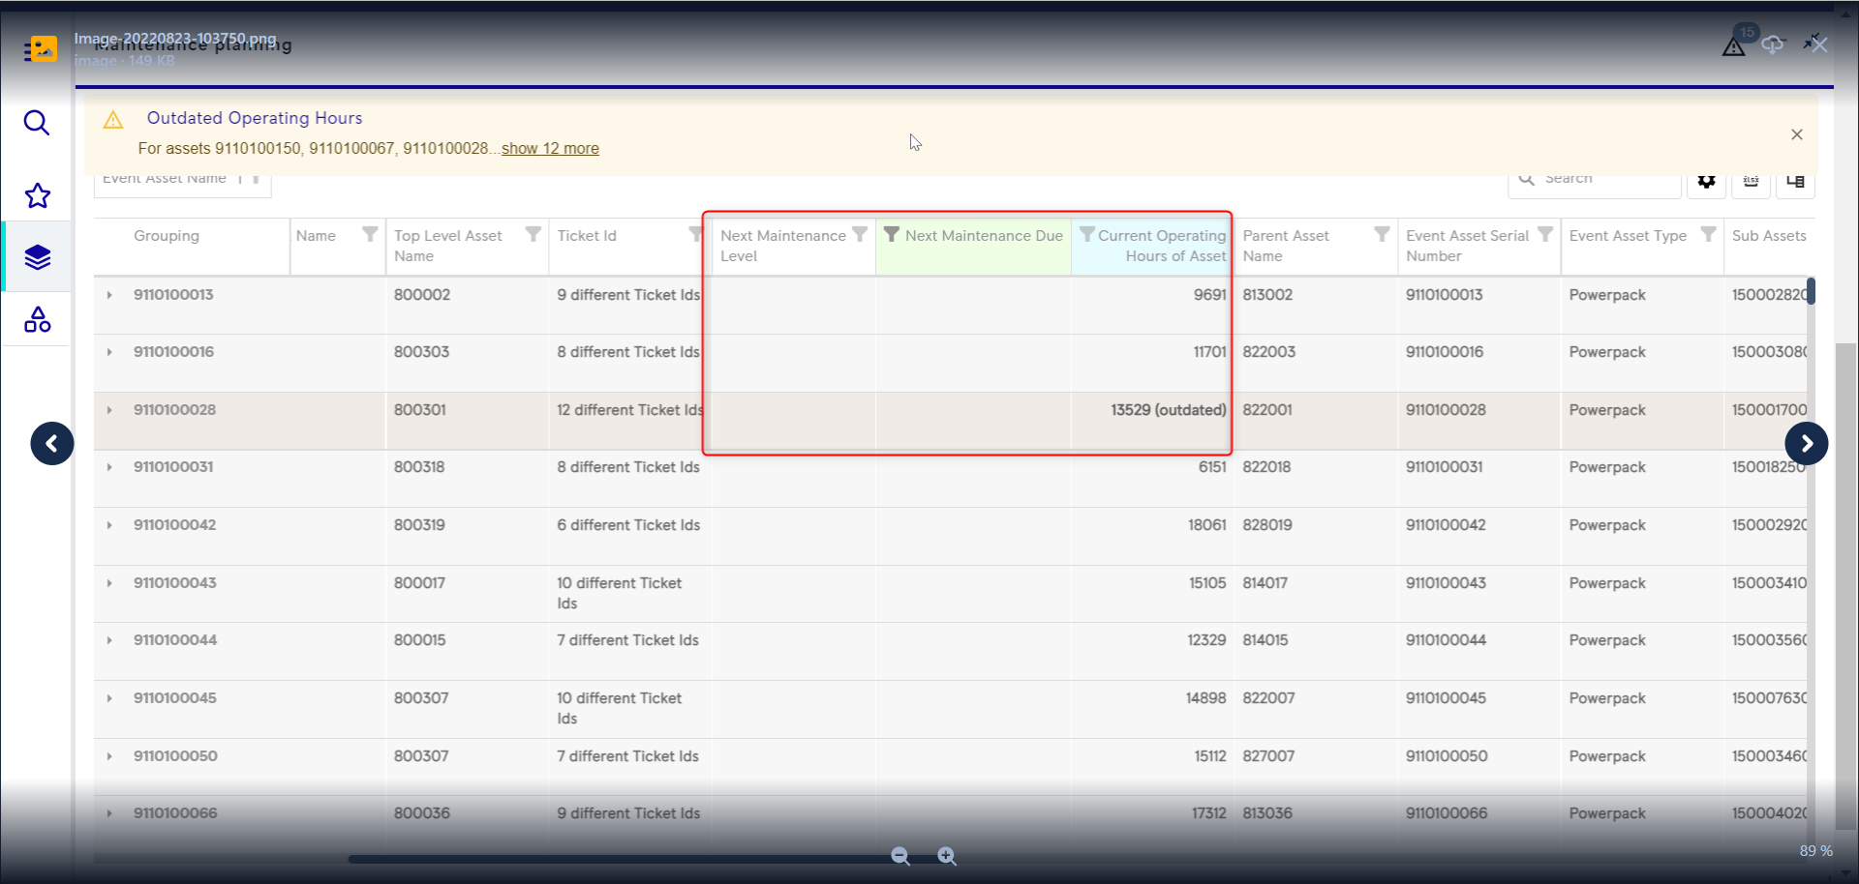

1. When user selects <asset> from <fleet>

And 'Next maintenance level' value is available

And 'operating hours' are not available

Then Due value should "“not applicable”

**Fleets: ECML (Maintenance level unit is yearly based for only these fleet as of now)**

##when Next maintenance level is 4.5 it’s like 4 and half years, so should add 4 years 6 months

**Formula 2 : NextMaintenanceDue (in days for ECML) =(CommissioningDate + NextMaintenanceLevel) - CurrentDate|**

1. When 'Maintenance Level Unit' is 'Y' (year based) – For ecml

And use <Formula2> for the UI calculation

Then verify the 'NextMaintenanceDue “cell value should match with the <formula2> output

1. When user selects <asset> from <fleet>

And 'Next maintenance level' value is available

And 'operating hours' are available

When the <formula2> output is '0' Then the '0' should be shown in the cell

13) Below column values will differ up on the type of assets that user selected.

**A) Selected asset Type** -- Always the selected asset (Can be PP/Train/Carriage depends on selection)

**B) Selected Asset Name** – Selected asset number

**C) Selected Asset serial number** -- Selected asset number

14) Latest completion hours

Latest completion hours = Due at operating hours + Tolerance hours

15) Earliest Begin hours

Earliest begin hours = Due at operating hours - Tolerance hours

15) Color Coding logic:

1. Red: [[GOS-2338] Verify compliance column's are in Red when the value exceeds the Tolerance limit - Jira (atlassian.net)](https://rrps-go.atlassian.net/browse/GOS-2338)
2. Value calculation is different for each column.

Applies to Columns

1. Due in Operating hours by interval operating hours / Due in Operating hours by interval operating hours Compliance
   1. The value (**Due at Operating hours by interval operating hours Compliance - Current operating hour ) should exceeds the tolerance limit**
2. Due at Days by Interval days Compliance column
   1. The Current date value should fall under below condition
   2. **(Current date value > due date Value + tolerance) then the value exceeded the tolerance limit**
3. Due in days by interval days Compliance
   1. The value should be (**Due at days by interval days Compliance- current date) should exceeds the tolerance limit**
4. **Yellow:**

[[GOS-2339] Verify compliance column's are in Yellow when the value is within the Tolerance limit - Jira (atlassian.net)](https://rrps-go.atlassian.net/browse/GOS-2339)

1. Value calculation is different for each column.

Applies to Columns

1. Due in Operating hours by interval operating hours Compliance
   1. The value (**Due at Operating hours by interval operating hours Compliance - Current operating hour) should be within the tolerance limit**
2. Due at Days by Interval days Compliance column
   1. The Current date value should fall under below condition
   2. **(current date Value > due date Value - tolerance) and**  
      **(Current date value < due date Value + tolerance) then the value is within tolerance limit**
3. Due in days by interval days Compliance
   1. The value should be (**Due at days by interval days Compliance- current date) should be within the tolerance limit**

**C: Green**

[[GOS-2337] Verify compliance column's are in Green when the values are Greater than the Tolerance limit - Jira (atlassian.net)](https://rrps-go.atlassian.net/browse/GOS-2337)

Applies to Columns

1. Due in Operating hours by interval operating hours Compliance
   1. The value **(Due at Operating hours by interval operating hours Compliance - Current operating hours) greater than tolerance limit**
2. Due at Days by Interval days Compliance column
   1. The Current date value should fall under below condition
   2. **current date value <= (due date Value - tolerance) Then the value is greater than tolerance limit**
3. Due in days by interval days Compliance
   1. The value should be (**Due at days by interval days Compliance- current date) should be greater than tolerance limit**

Example:

Asset A **Due at Operating hours by interval operating hours** is 3000

Asset A current operating hours

Asset A Tolerance limit is -150 to 150 or -30 to +30 days

If the Value is >150 then Green

If the value falls between -150 to +150 Then its yellow

If the value is <-150 then Red

**Color Coding logic for 'Next Maintenance Due' column:**

* 1. If 'Maintenance Level Unit' is 'H' (hours based):  
     ToleranceMinWindow = NextMaintenanceLevel - toleranceOperatingHours  
     ToleranceMaxWindow = NextMaintenanceLevel + toleranceOperatingHours

If (CurrentOphrs > toleranceWindowMax): color = 'red'  
If (CurrentOphrs >= toleranceWindowMin && CurrentOphrs <= toleranceWindowMax): color = 'yellow'  
If (CurrentOphrs < toleranceWindowMin): color = 'green'

* 1. When 'Maintenance Level Unit' is 'Y' (Yearly based)

And If (NextMaintenanceDue > 30) ##30 days

Then the column color should be 'red'

When 'Maintenance Level Unit' is 'Y' (Hourly based)

And If (NextMaintenanceDue >= 30 )

And the NextMaintenanceDue <= 60)

Then the column color should be 'yellow'

When 'Maintenance Level Unit' is 'Y' (Hourly based)

And If (NextMaintenanceDue >= 60) ##60 days

Then the column color should be 'Green'

**Color coding For Predicated date:**

1. When the **Predicted date is less than 30 days with comparison to current date** then show in Red Color
2. When the **Predicted** **date is between 30 days & 60 days** then show in Yellow
3. When the **Predicted date is longer than 60 days** **with comparison to current date** show in Green Color
4. coding to be displayed at an aggregate level i.e., if one row is red, the whole Parent level should be red and so on for yellow and green

**Color coding at Aggregate level:**

1) When any one of the rows of the data is red Then Red color should be displayed on the aggregate level

2) When None of the row is in red color and one of the rows of the data is yellow

Then the Yellow color should be displayed on the aggregate level

3)When None of the row is in red color And None of the rows of the data is yellow

Then the Green color should be displayed on the aggregate level

4) When the grouping criteria are changed but then the color coding on the column is retained

5) When the sorting is applied on the table but then the color coding on the column is retained